**BANK LOAN REPORT QUERY DOCUMENT**

1. **BANK LOAN REPORT | SUMMARY**

**KPI’s:**

1. **Total Loan Application**

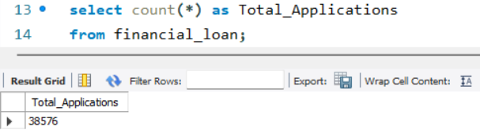

1. **MTD Loan Applications**

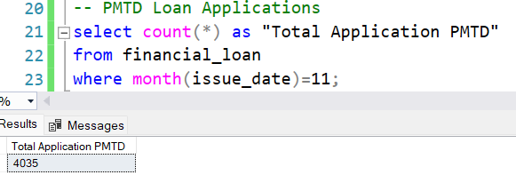

1. **MTD Loan Applications**

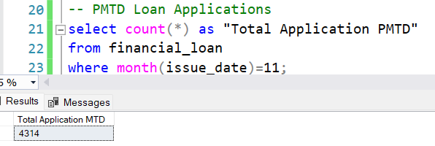

1. **Total Funded Amount**

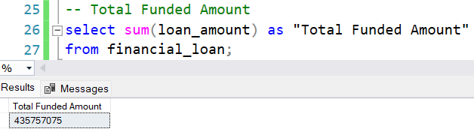

1. **MTD Total Funded Amount**

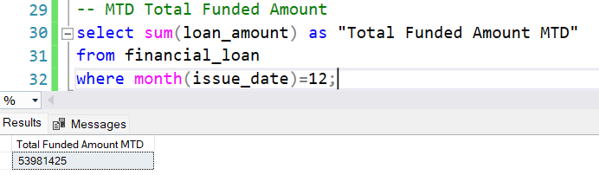

1. **PMTD Total Funded Amount**

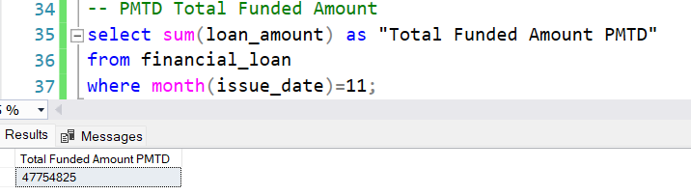

1. **Total Received Amount**

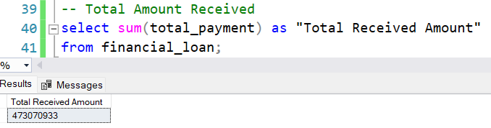

1. **MTD Total Amount Received**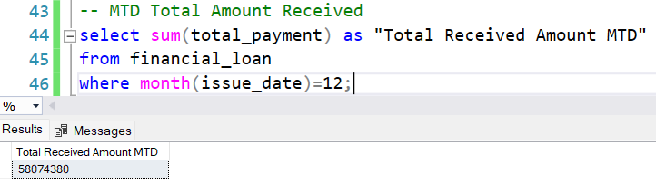
2. **PMTD Total Amount Received**

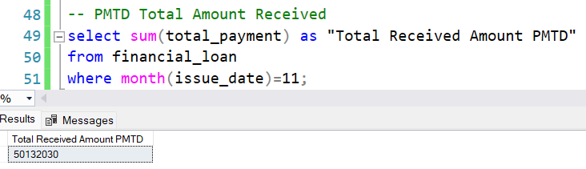

1. **Average Interest Rate**

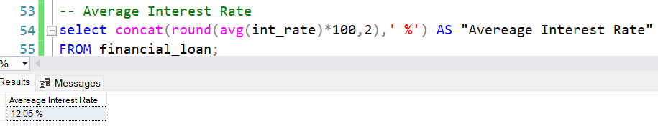

1. **MTD Average Interest Rate**

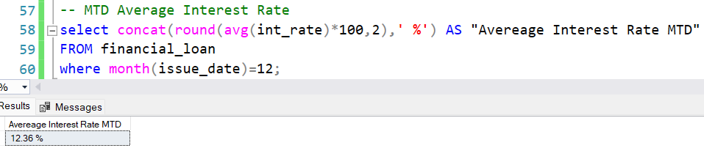

1. **PMTD Average Interest Rate**

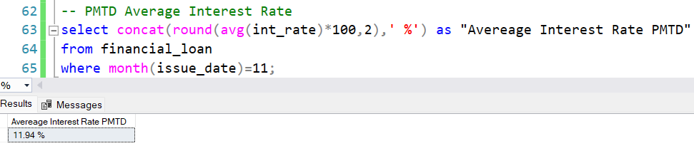

1. **Average DTI**

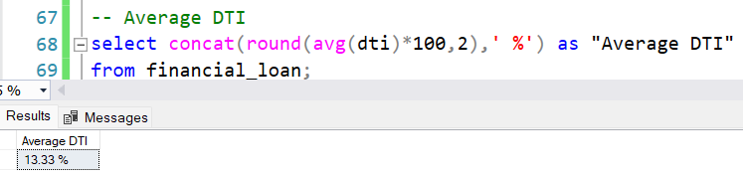

1. **MTD Average DTI**

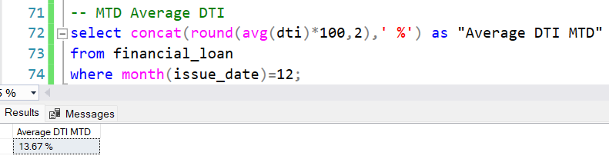

1. **PMTD Average DTI**

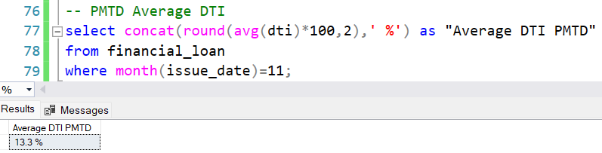

**GOOD LOAN ISSUED**

1. **Good Loan Percentage**

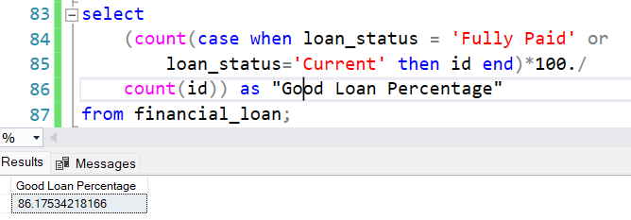

1. **Total Good Laon Application**

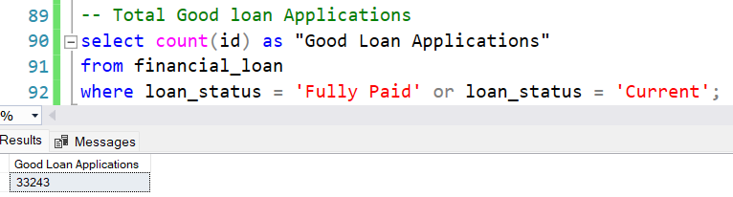

1. **Total Good Loan Funded Amount**

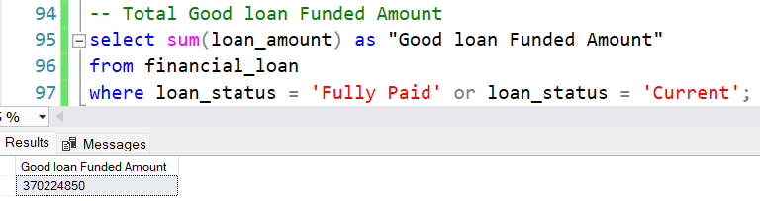

1. **Total Good Loan Received Amount**

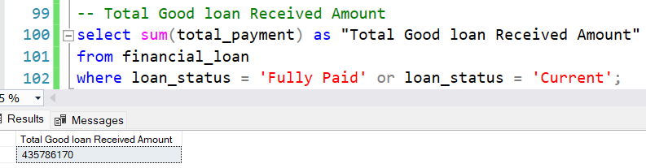

**BAD LOAN ISSUED**

1. **Bad Loan Percentage**

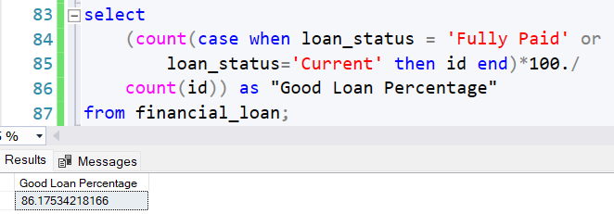

1. **Total Bad Loan Application**

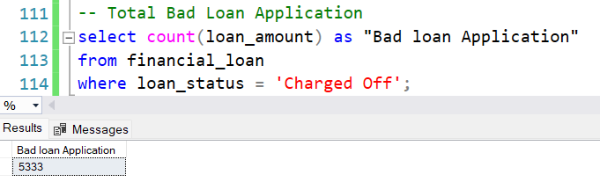

1. **Total Bad Loan Funded Amount**

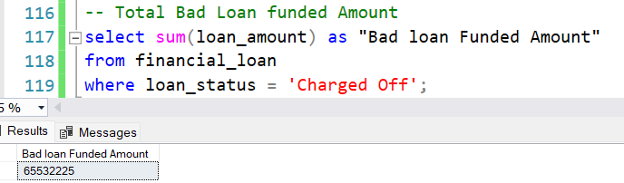

1. **Total Bad Loan Received Amount**

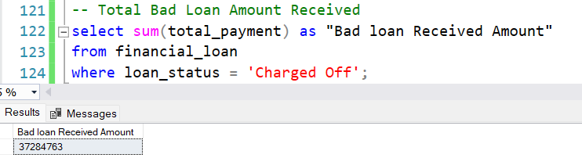

**Loan Status**

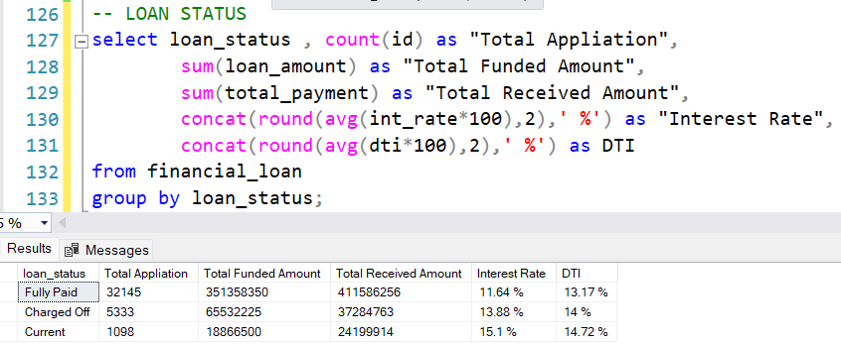

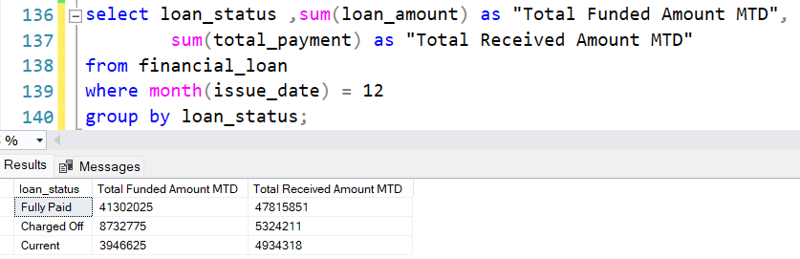

1. **BANK LOAN REPORT | OVERVIEW**
2. **Month**

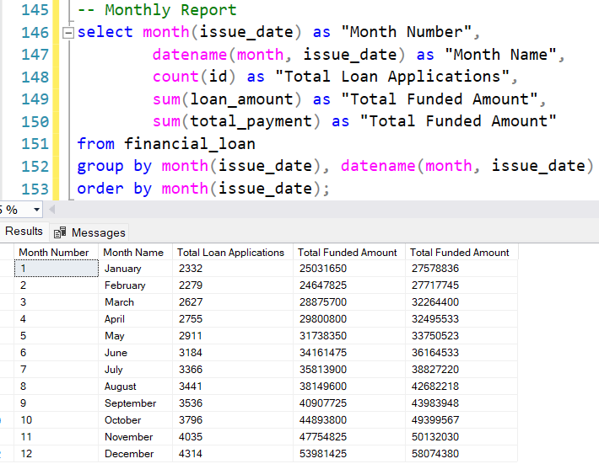

1. **State**

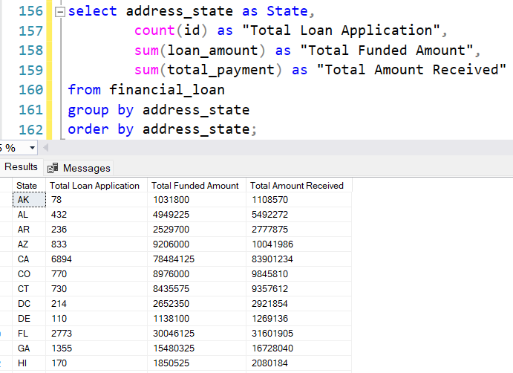

1. **Term**

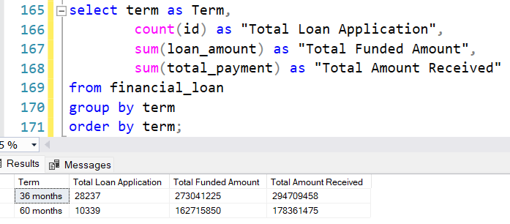

1. **Employee Length**

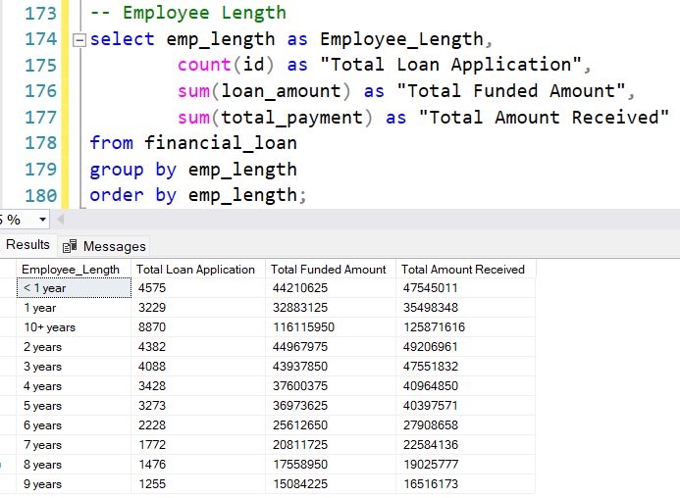

1. **Purpose**

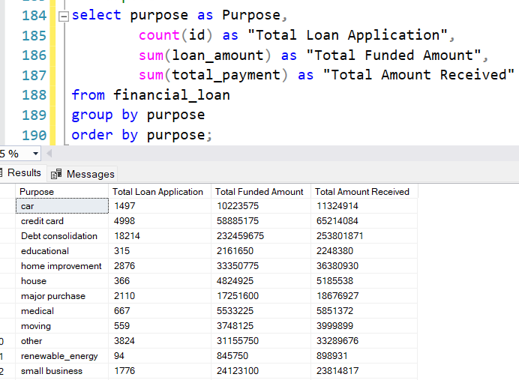

1. **Home Ownership**

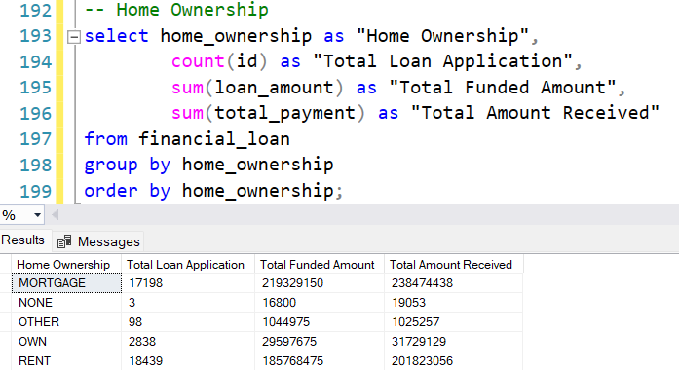

1. **Purpose OR Grade “A”**

